Programming Language Research Project

Course: CST 8002-040 Programming Languages Research Project
Assignment: Research Assignment 04
Instructor: Tyler DeLay
Student Name: Qinyu Luo
Student ID: 041137796
Due Date: 11/21
Submitted: 11/21
1. Development Environment Changes
Current Development Environment
Programming Language: Node.js
Version: v22.21.0 (Latest LTS)
Package Manager: npm 10.9.4
Framework: Express.js (assumed - please confirm)
Database: [To be confirmed - MySQL/MongoDB/PostgreSQL/None]
Environment Status
No changes to the development environment since Practical Project Part 3. The environment remains stable and consistent with previous project parts, ensuring compatibility and continuity for Practical Project Part 4 implementation.
All dependencies and tools from Parts 1, 2, and 3 remain unchanged and will continue to be used for Part 4.
2. Research and Learning Resources
Selected Feature for Implementation
Feature: Multi-column Searching, Sorting, and Filtering
This feature will allow users to search, sort, and filter data across multiple columns simultaneously, providing enhanced data manipulation and user experience.
Research Findings and Implementation Approach
Option 1: Build Custom Solution
Approach: Implement custom sorting and filtering logic using native JavaScript array methods.
Advantages:
- Full control over implementation
- No external dependencies
- Optimized for specific use case
- Better understanding of algorithms
Resources:
- MDN Web Docs on Array methods (sort, filter, map) [1]
- JavaScript.info on Array sorting and filtering [2]
Option 2: Adopt Third-Party Libraries
After researching available libraries for Node.js multi-column data manipulation, the following options were identified:
Recommended Library: Lodash
Library: Lodash
License: MIT License (Free for commercial and non-commercial use)
Purpose: Utility library with powerful data manipulation functions
Key Features:
- _.sortBy() - Multi-column sorting
- _.filter() - Advanced filtering
- _.orderBy() - Sorting with multiple criteria and directions
- Well-tested and maintained
- Extensive documentation and community support
Installation:
bash
npm install lodash
Usage Example:
javascript
const _ = require('lodash');

// Multi-column sorting
const sortedData = _.orderBy(data,
['column1', 'column2', 'column3'],
['asc', 'desc', 'asc']
);

// Multi-column filtering
const filteredData = _.filter(data, item => {
return item.column1 === value1 &&
item.column2 > value2 &&
item.column3.includes(value3);
});
Why Lodash:
- Industry standard with over 56 million weekly downloads
- MIT License - completely free
- Actively maintained (last update within months)
- Excellent documentation
- Compatible with Node.js and browser environments
- Performance optimized
Resources:
- Lodash Official Documentation [3]
- Lodash GitHub Repository [4]
- MIT License Information [5]
Alternative: DataTables (for web-based projects)
Library: DataTables
License: MIT License
Purpose: jQuery plugin for advanced table interactions
Features:
- Built-in multi-column sorting
- Server-side or client-side processing
- Search and filter capabilities
- Pagination
Note: Requires jQuery, which may add overhead if not already in use.
Recommended Implementation Strategy
Hybrid Approach:
- Business Layer: Use Lodash for data manipulation logic
  - Implement sorting functions using _.orderBy()
  - Implement filtering functions using _.filter() and custom predicates
  - Keep business logic separate from presentation
- Presentation Layer: Handle user input and display results
  - Create UI for column selection
  - Display sorted/filtered results
  - Maintain separation of concerns (Hybrid 05 principles)
- Persistence Layer (if using database):
  - For small datasets: retrieve all data and process in business layer
  - For large datasets: implement database queries for performance
  - Use parameterized queries to prevent SQL injection
Rationale:
- Lodash is a well-established, free library that saves development time
- Provides reliable, tested functionality
- Allows focus on project-specific features
- Follows industry best practices
- Maintains clean architecture with proper layer separation
Architecture Considerations (Based on Hybrid 05)
Following the MVC/Layered Architecture principles:
Presentation Layer (View):
- User interface for selecting columns to search/sort/filter
- Display results in formatted table or list
- Handle user interactions (clicks, input)
Business Layer (Controller/Model):
- Process search/sort/filter requests
- Apply Lodash functions to manipulate data
- Validate user input
- Format data for presentation
Persistence Layer (if applicable):
- Retrieve data from database
- Execute optimized queries for large datasets
- Return data to business layer
This ensures proper separation of concerns and maintains scalability for future deployment as a distributed system.
4. Gantt Chart
Gantt Chart Overview
A Gantt chart has been created in ProjectLibre showing the project timeline with the following elements:
- Tasks and Sub-tasks: All WBS items listed above with proper indentation
- Duration: Estimated in days for each task
- Dependencies: Sequential tasks linked appropriately
- Milestone: "Practical Project Part 4 Delivered" set to the due date
- Resources: Student name assigned to tasks
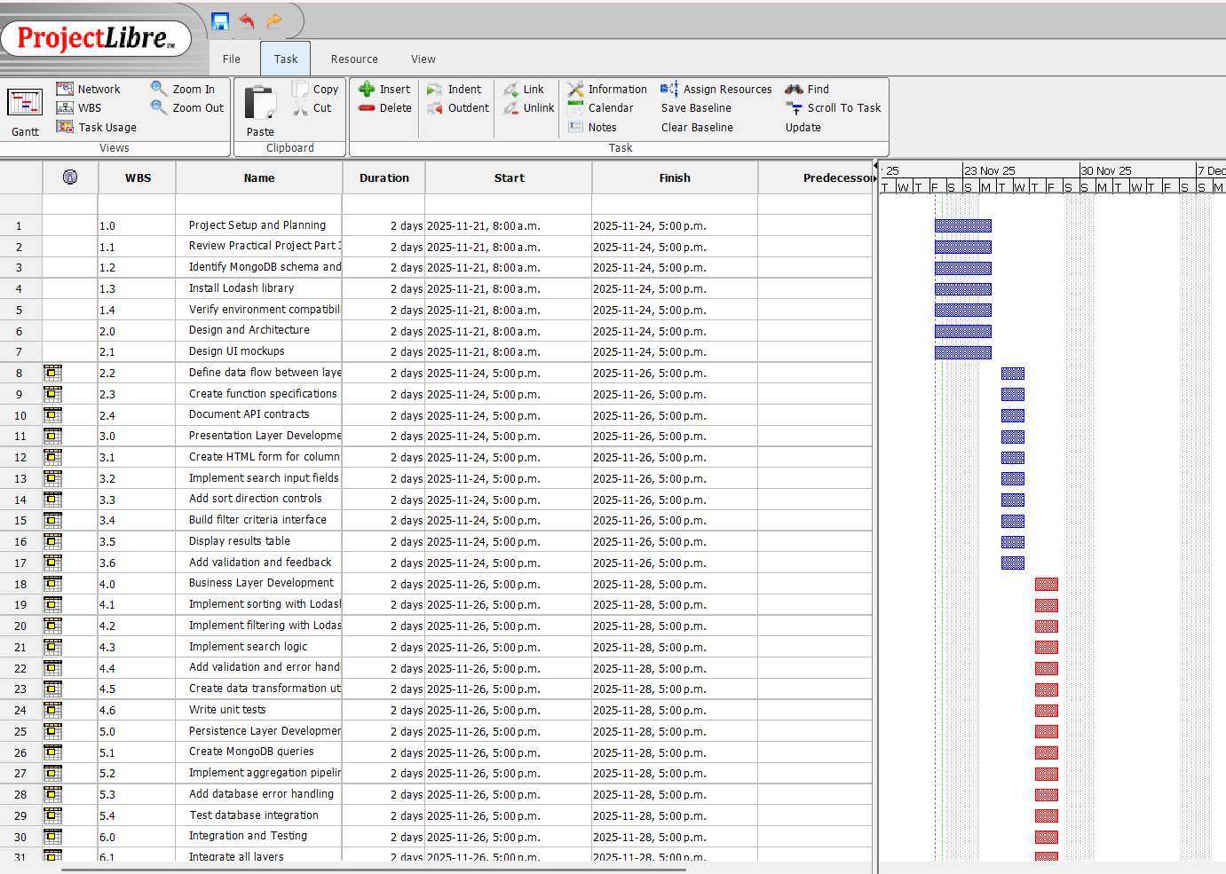

References
[1] Mozilla Developer Network. (n.d.). Array - JavaScript | MDN. developer.mozilla.org. [online]. Available at: https://developer.mozilla.org/en-US/docs/Web/JavaScript/Reference/Global_Objects/Array [Accessed on 21 Nov 2025]
[2] JavaScript.info. (n.d.). Array methods. javascript.info. [online]. Available at: https://javascript.info/array-methods [Accessed on 21 Nov 2025]
[3] Lodash. (n.d.). Lodash Documentation. lodash.com. [online]. Available at: https://lodash.com/docs/ [Accessed on 21 Nov 2025]
[4] Lodash. (n.d.). lodash/lodash: A modern JavaScript utility library delivering modularity, performance, & extras. GitHub. [online]. Available at: https://github.com/lodash/lodash [Accessed on 21 Nov 2025]
[5] Open Source Initiative. (n.d.). The MIT License. opensource.org. [online]. Available at: https://opensource.org/licenses/MIT [Accessed on 21 Nov 2025]
[6] University of York. (2024, Oct, 16). IEEE referencing Style. Referencing styles – a Practical Guide. [online]. Available at: https://subjectguides.york.ac.uk/referencing-style-guides/ieee [Accessed on 5 Nov 2024]

